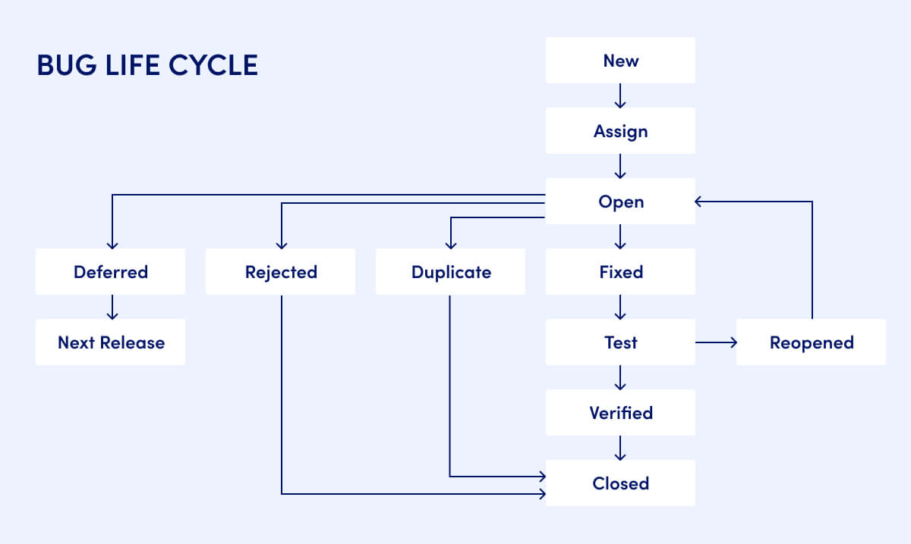

**Bug Life Cycle**

The **Bug Life Cycle** (also known as *Defect Life Cycle*) describes the journey of a software bug from the moment it is reported until it is resolved and closed. This cycle helps software teams manage defects systematically, ensuring accountability, proper fixes, and quality assurance before release. The figure below illustrates the standard bug life cycle stages:

**Stages in the Bug Life Cycle**

1. **New**  
   When a tester identifies a bug, it is logged into the defect tracking system and marked as “New.” At this point, no action has been taken.
2. **Assign**  
   The bug is assigned to a developer or team for investigation and resolution. Assignment usually depends on module ownership or expertise.
3. **Open**  
   The developer reviews the bug, analyzes it, and decides on the next step. The bug may be accepted for fixing or moved to other states (like *Rejected*, *Deferred*, or *Duplicate*).
4. **Rejected**  
   If the developer determines the bug is invalid (e.g., due to misconfiguration, misunderstanding, or environment issues), it is marked as *Rejected*.
5. **Deferred**  
   Sometimes, fixing the bug is postponed to a later release due to low priority, limited resources, or non-critical impact. It is labeled as *Deferred* and planned for the *Next Release*.
6. **Duplicate**  
   If the bug is already reported in another ticket, it is marked as *Duplicate* to avoid redundancy.
7. **Fixed**  
   When the developer implements a solution, the bug status changes to *Fixed*. The fix is submitted for testing.
8. **Test**  
   The QA team tests the application with the fix applied. If the bug still exists, the status changes to *Reopened*. If it works correctly, the cycle continues.
9. **Reopened**  
   If the defect persists after testing, the bug is reopened and sent back to the developer for further analysis and correction.
10. **Verified**  
    If the fix is confirmed by the QA team and no further issues are found; the bug is marked as *Verified*.
11. **Closed**  
    Finally, if the verified bug no longer poses any issues, the defect is marked as *Closed*. At this point, the life cycle is complete.

**References**

* Executive Automats. *What is Bug Life Cycle in Manual Testing?* <https://www.executiveautomats.com/resources/articles/what-is-bug-life-cycle-in-manual-testing>